
LOT CODE: 26815
BEST BEFORE:2027/02/15
Lava Cake 3 Inch
ITEM #GP2118
KEEP
FROZEN

Ingredients: Eggs, sugar, wheat flour, margarine (modified palm oil, water, monoglycerides, potassium sorbate, citirc acid, natural flavor, vitamin A palmitate, vitamin D3) Dark Chocolate (sugar, cocoa butter, blegian unsweetened chocolate, soy licithin, natural anilla extract) stabilizer, coating chocolate(sugar, non hydrogenated fats, smulsifier ,coco powder).

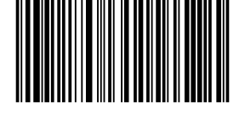
(01)10627146285749(15)250923(10)72722

Gastronomique pastry INC
7621 vantage way, Delta, BC V4G 1A6

